# Exercise 2: Swagger & Postman Hands-on

WEEK4_EXERCISE2_SWAGGER&POSTMAN HANSON

## Objectives

* - Demonstrate Swagger installation to Web API and listing in browser
* - Install Swashbuckle.AspNetCore and configure AddSwaggerGen, UseSwagger, and UseSwaggerUI
* - Use ProducesResponseType attribute on Web API methods for response documentation
* - Demonstrate usage of Postman to hit Web API methods: collections, headers, JSON body, HTTP methods
* - Demonstrate usage of Route attribute and ActionName for friendly action method names
* - Modify controller route to a custom name (e.g., "api/emp") and verify via Postman

## Step-by-Step Implementation

1. Created a .NET Core Web API project named "Exercise2_SwaggerAndPostman" in Visual Studio 2022.

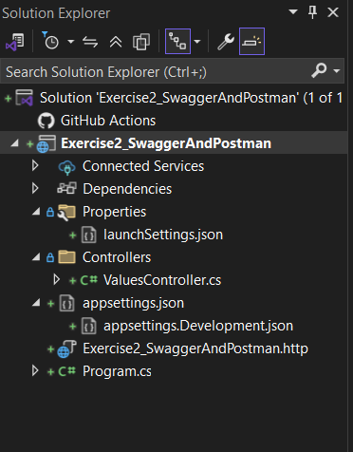

1. Added and configured Swagger:  
    • Installed Swashbuckle.AspNetCore NuGet package  
    • Added services.AddSwaggerGen(...) in Program.cs  
    • Called app.UseSwagger() and app.UseSwaggerUI(...) with correct endpoint and RoutePrefix in Program.cs

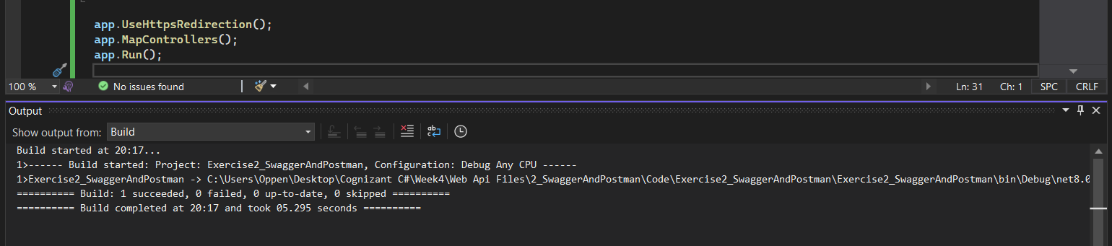

1. Annotated action methods with [ProducesResponseType] attributes to document status codes.

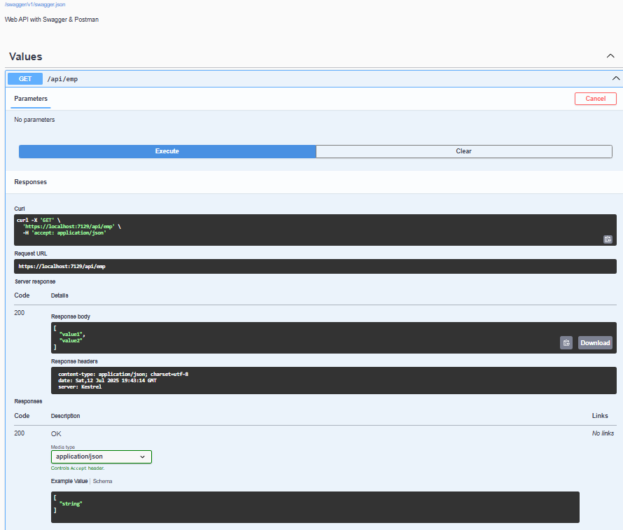

1. Built and ran the application, then browsed to https://localhost:<port>/swagger to view the interactive Swagger UI.
2. 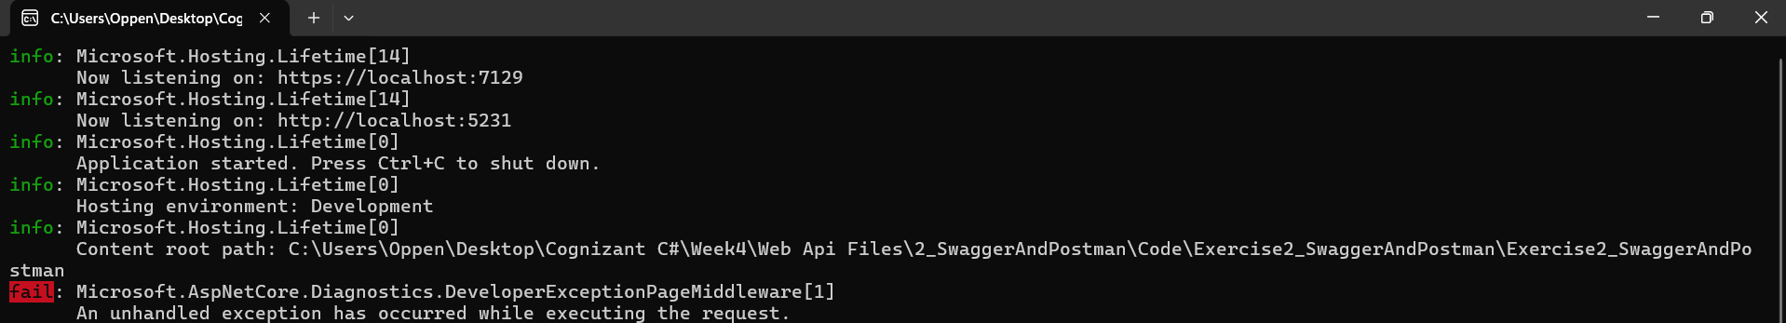
3. . Clicked GET /api/values, selected "Try it out", then "Execute" to see 200 response and example JSON.
4. 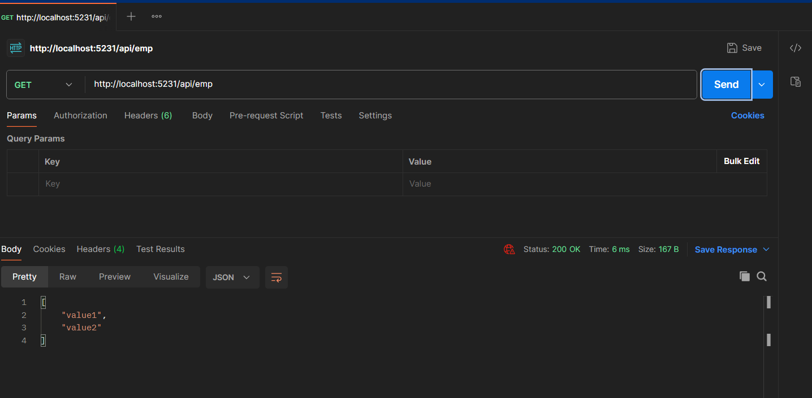
5. Opened Postman:  
    • Disabled SSL certificate verification  
    • Created a GET request to http://localhost:<http-port>/api/values  
    • Verified status 200 and response body in Postman
6. Updated the ValuesController [Route] attribute to [Route("api/emp")], rebuilt and reran.
7. . In Postman, sent GET to http://localhost:<http-port>/api/emp and verified the renamed route works.

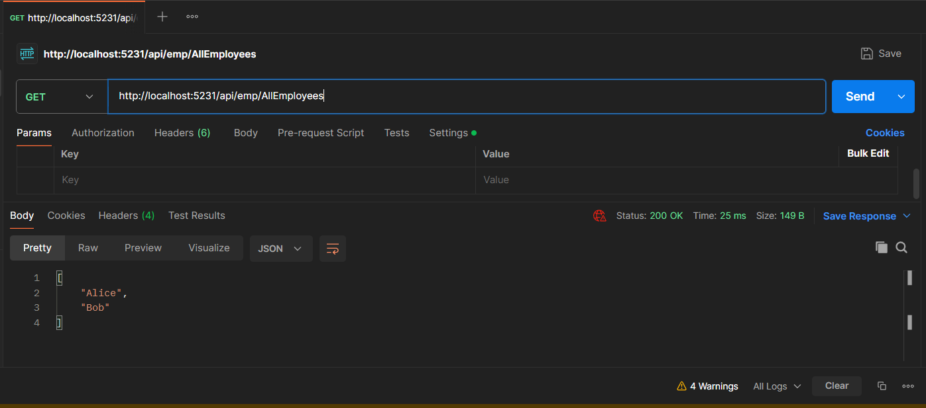

1. . Demonstrated friendly action name:  
    • Added [HttpGet, ActionName("AllEmployees")] to the GetAll method  
    • Observed the ActionName in Swagger UI and executed the endpoint AllEmployees

